**Hands on Exercise**

In this Hands-On Practice you will create the web page shown in [**Figure 8.9**](https://jigsaw.vitalsource.com/books/9780133971026/epub/OPS/xhtml/fileP7000495062000000000000000002615.xhtml#P700049506200000000000000000261C), which displays a group of images with captions.

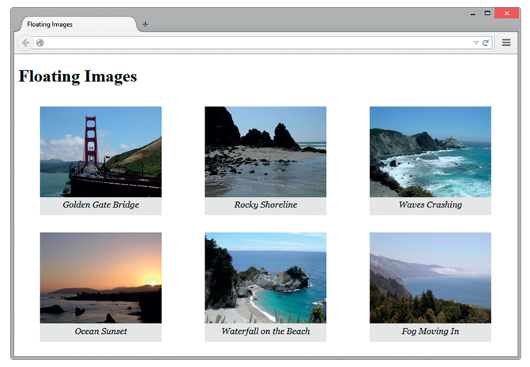

**Figure 8.9 *The images float in this web page.***

You’ll configure the images and their captions to float on the web page to fill the available space in the browser viewport. The display will change based on the size of the browser viewport.

[**Figure 8.10**](https://jigsaw.vitalsource.com/books/9780133971026/epub/OPS/xhtml/fileP7000495062000000000000000002615.xhtml#P7000495062000000000000000002623) shows the same web page displayed in a browser that has been resized to be smaller.

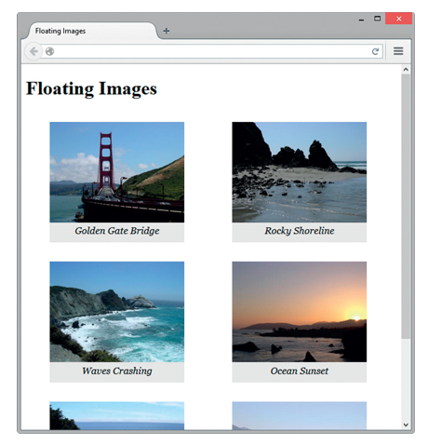

**Figure 8.10 *The floated images move as the browser is resized.***

Create a new folder named float8. Copy the following images from the student files starters folder into the float8 folder: photo1.png, photo2.png, photo3.png, photo4.png, photo5.png, and photo6.png.

Launch a text editor and open the template file located at chapter1/template.html in the student files. Save the file as index.html in your float8 folder. Modify the file to configure a web page as indicated:

1. Configure the text, Floating Images, within an h1 element and the title element.
2. Code six figure elements, one for each image. Within each figure element, configure an image element and a figcaption element with an appropriate text description of the image. An example of the first figure element is

<figure>

 <img src="photo1.png" alt="Golden Gate Bridge"

width="225" height="168">

 <figcaption>Golden Gate Bridge</figcaption>

</figure>

1. Configure all six figure elements in a similar manner. Substitute the actual name of each image file for the src values in the code. Write your own descriptive text for each image. Use photo2.png in the second figure element, photo3.png in the third figure element, photo4.png in the fourth figure element, photo5.png in the fifth figure element, and photo6.png in the sixth figure element. Save the file. Display your page in a browser. [**Figure 8.11**](https://jigsaw.vitalsource.com/books/9780133971026/epub/OPS/xhtml/fileP7000495062000000000000000002615.xhtml#P7000495062000000000000000002638) shows a partial screen capture.

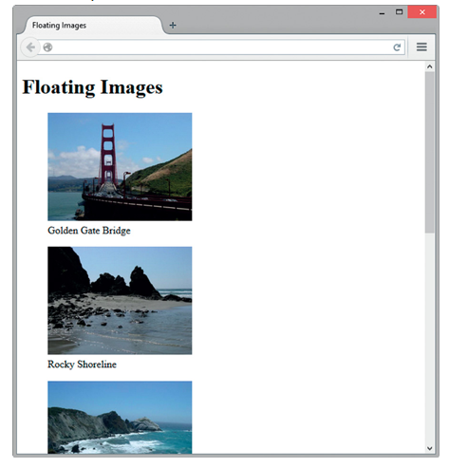

**Figure 8.11 *The web page before CSS.***

1. Now, let’s add embedded CSS. Open your file in a text editor and code a style element in the head section. Configure the figure element selector to float to the left. Also set the width to 225 pixels, bottom padding to 10 pixels, and background color to light gray (#EAEAEA). Configure the figcaption element selector to display centered, italic text in the Georgia (or other serif) font. The CSS follows

figure { float: left;

width: 225px;

padding-bottom: 10px;

background-color: #EAEAEA; }

figcaption { text-align: center;

font-style: italic;

font-family: Georgia, serif; }

Save your page and display it in a browser. Experiment with resizing the browser window to see the display change. Compare your work with [**Figures 8.9**](https://jigsaw.vitalsource.com/books/9780133971026/epub/OPS/xhtml/fileP7000495062000000000000000002615.xhtml#P700049506200000000000000000261C) and [**8.10**](https://jigsaw.vitalsource.com/books/9780133971026/epub/OPS/xhtml/fileP7000495062000000000000000002615.xhtml#P7000495062000000000000000002623). A sample solution is in the student files (chapter8/8.4/index.html).

1. Next, let’s explore an alternate approach to “floating” elements. Instead of using the float property, you’ll set the display property to inline block. Launch a text editor and open the index.html file. Save the file with a new name, index2.html. Modify the embedded CSS by replacing the float: left; property with display: inline-block;. Save your page and display it in a browser. Experiment and see the display change. Compare your work with [**Figures 8.9**](https://jigsaw.vitalsource.com/books/9780133971026/epub/OPS/xhtml/fileP7000495062000000000000000002615.xhtml#P700049506200000000000000000261C) and [**8.10**](https://jigsaw.vitalsource.com/books/9780133971026/epub/OPS/xhtml/fileP7000495062000000000000000002615.xhtml#P7000495062000000000000000002623). A sample solution is in the student files (chapter8/8.4/index2.html).